## 

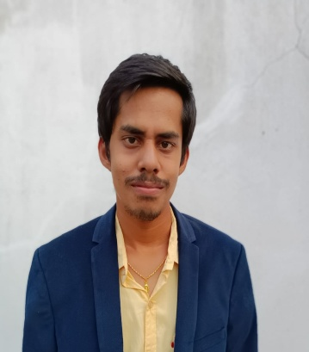

## Work Experience

Puligadda Siv Sri Datt

Kesava Sarma

[keshavadattha@gmail.com](mailto:keshavadattha@gmail.com)



25/11 2024 -

25/12/2024

TechGrow IT Benguluru,India India

* Worked in Front-end Development domain.
* Developed website elements using HTML,CSS,JavaScript.
* Implemented responsive design principles to adopt across various devices.
* Utilized Front-end Framework React.
* Employed version control system like Git to manage code changes.

+91-7569789595

13/06/2001

Indian



Siv sri datt kesava sarma



https://github.com/Keshavadattha

## Functional skill

## Quick learning creativity

## Performing under pressure

## Adaptable to work environment

## Self learning

## Proactive communication

Hobbies

Enjoying music

Brushing up my knowledge

## Education

B.Tech in Civil Engineering

Swarna Bharathi Institute of Science and Technology

2019 – 2023

CGPA: 6.38/10

## Technical Skills

Programming: Python

Database: MySQL

Operating system: Linux

Frameworks: React

Web Technologies: HTML, CSS, JavaScript

VersionControl: GitHub

# Projects

My online portfolio website

Developed an online portfolio website using HTML,

CSS, and JavaScript. I showcased my education, skills,

projects, hobbies, and contact details with a visually

appealing and interactive design.

Link: https://github.com/Keshavadattha/my-portfolio-website.git

Quote generator website

Developed a static web page showcasing famous quotes from Bhagavad Gita in a randomized fashion to engageusers. Curated a comprehensive overview of all chapters in Bhagavad Gita, enhancing users’ understanding of the scrip- ture’s teachings.

Link: https://github.com/Keshavadattha/Tech_Grow-Task.git

Chatting Application Website Using React

The user facing part of chat system responsible for displaying

the chat interface

Allowing users to input message , and virtually presenting

incoming message while interacting with server to send and

receive data

Link: https://github.com/Keshavadattha/Chat-App.git

Khammam, Telangan